The Secret to a Fabulous Marriage
Wisdom from the Book of Proverbs


Every married couple wants to have a great marriage, so why do so many fail to experience it? No two marriages are the same, but wise husbands and wives heed the advice in Proverbs. Here are sure-fire ways to have a great marriage.

The Wise Husband…

- _____________ his wife. (Prov. 18.22)

- _______________ his wife. (Prov. 31.28-29)

- Is ________________ to his wife. (Prov. 5.15-17, 20-23)

- Is ____________________ toward his wife. (Prov. 5.18-19)

The Wise Wife…

- ___________________ her husband. (Prov. 12.4; 31.23)

- Gives ________________ to her husband. (Prov. 14.1; 31.11)

- Is _________________ to her husband. (Prov. 2.16-19; 21.9, 19)

- _________________ for her husband. (Prov. 31.10, 13-25)

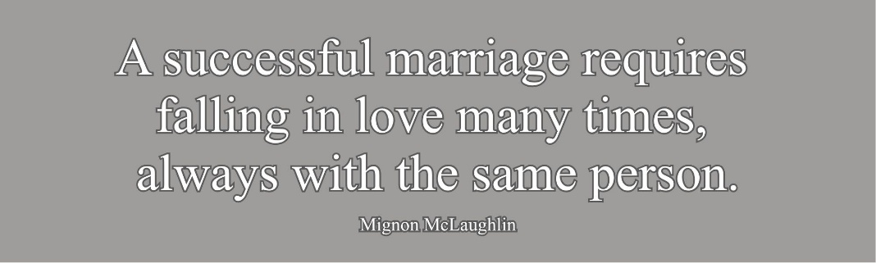

Digging Deeper

- According to Dr. Gary Chapman, there are five “love languages”
– ways husbands and wives express emotional affection with their marriage partners. These are:

- Words of Affirmation (praise, compliments; kind or encouraging words; hearing “I love you”)
- Quality Time (undivided attention; phones put away, meaningful talks or shared activities)
- Receiving Gifts (thoughtful tokens; visual symbols of love; the effort behind the gift)
- Acts of Service (helpful actions; doing chores or tasks; easing daily burdens)
- Physical Touch (hugs and kisses; holding hands; close physical presence and intimacy)

For both husbands and wives: What is your love language? What do you think your spouse’s love language is? What does your spouse say their love language is? How can you better express your love in ways that effectively ‘communicate’ with your spouse?

- For husbands: Consider the wise advice of Proverbs for husbands. In what ways are you making your marriage fabulous? In what ways could you make it even better?

- For wives: Consider the wise advice of Proverbs for wives. In what ways are you making your marriage fabulous? In what ways could you make it even better?

- Hebrew scholar Bruce Waltke sums up what the Book of Proverbs says to husbands and wives this way: In sum, husband and wife journey together in a spirit of humility and faith in God, express their love in each other’s embrace and in open correction of each other, and confess and renounce their inevitable sins as they extend mercy to each other (Bruce K. Waltke, The Book of Proverbs, 2 vols., 1.118). Are you reflecting wisdom in your marriage?

The Secret to a Fabulous Marriage
Wisdom from the Book of Proverbs

Every married couple wants to have a great marriage, so why do so many fail to experience it? No two marriages are the same, but wise husbands and wives heed the advice in Proverbs. Here are sure-fire ways to have a great marriage.

The Wise Husband…

- _____________ his wife. (Prov. 18.22)

- _______________ his wife. (Prov. 31.28-29)

- Is ________________ to his wife. (Prov. 5.15-17, 20-23)

- Is ____________________ toward his wife. (Prov. 5.18-19)

The Wise Wife…

- ___________________ her husband. (Prov. 12.4; 31.23)

- Gives ________________ to her husband. (Prov. 14.1; 31.11)

- Is _________________ to her husband. (Prov. 2.16-19; 21.9, 19)

- _________________ for her husband. (Prov. 31.10, 13-25)

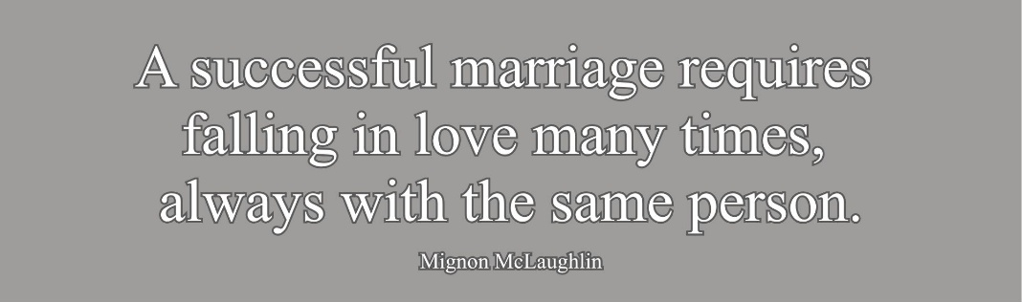

Digging Deeper

- According to Dr. Gary Chapman, there are five “love languages” – ways husbands and wives express emotional affection with their marriage partners. These are:

- Words of Affirmation (praise, compliments; kind or encouraging words; hearing “I love you”)
- Quality Time (undivided attention; phones put away, meaningful talks or shared activities)
- Receiving Gifts (thoughtful tokens; visual symbols of love; the effort behind the gift)
- Acts of Service (helpful actions; doing chores or tasks; easing daily burdens)
- Physical Touch (hugs and kisses; holding hands; close physical presence and intimacy)

For both husbands and wives: What is your love language? What do you think your spouse’s love language is? What does your spouse say their love language is? How can you better express your love in ways that effectively ‘communicate’ with your spouse?

- For husbands: Consider the wise advice of Proverbs for husbands. In what ways are you making your marriage fabulous? In what ways could you make it even better?

- For wives: Consider the wise advice of Proverbs for wives. In what ways are you making your marriage fabulous? In what ways could you make it even better?

- Hebrew scholar Bruce Waltke sums up what the Book of Proverbs says to husbands and wives this way: In sum, husband and wife journey together in a spirit of humility and faith in God, express their love in each other’s embrace and in open correction of each other, and confess and renounce their inevitable sins as they extend mercy to each other (Bruce K. Waltke, The Book of Proverbs, 2 vols., 1.118). Are you reflecting wisdom in your marriage?

